**Modul 9**

Nama : Andrias Sigid W.R

NIM : L200144010

Percobaan 1

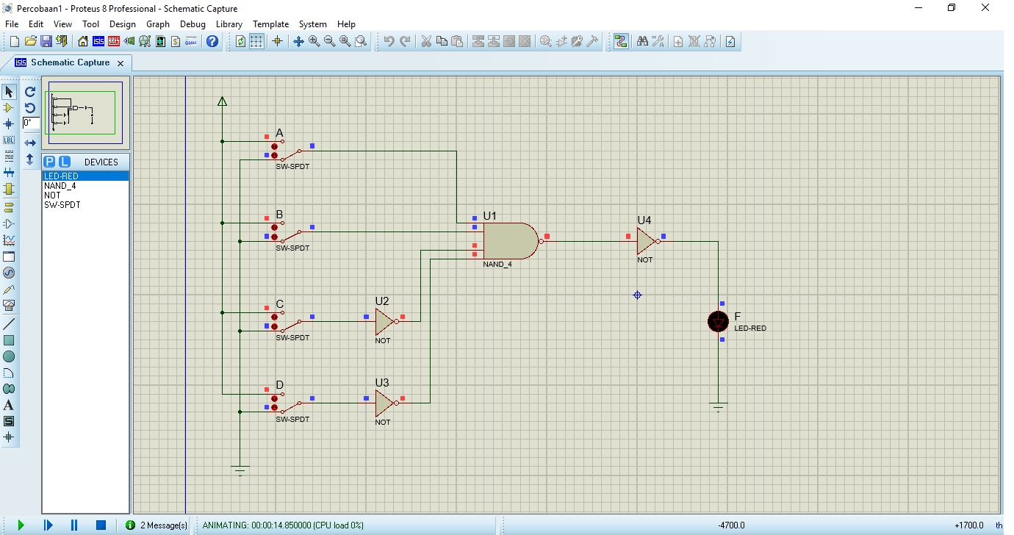

|  |  |  |  |  |
| --- | --- | --- | --- | --- |
| A | B | C | D | F |
| 0 | 0 | 0 | 0 | 0 |
| 1 | 0 | 0 | 0 | 0 |
| 0 | 1 | 0 | 0 | 0 |
| 1 | 1 | 0 | 0 | 1 |
| 0 | 0 | 1 | 0 | 0 |
| 1 | 0 | 1 | 0 | 0 |
| 0 | 1 | 1 | 0 | 0 |
| 1 | 1 | 1 | 0 | 0 |

|  |  |  |  |  |
| --- | --- | --- | --- | --- |
| A | B | C | D | F |
| 0 | 0 | 0 | 1 | 0 |
| 1 | 0 | 0 | 1 | 0 |
| 0 | 1 | 0 | 1 | 0 |
| 1 | 1 | 0 | 1 | 1 |
| 0 | 0 | 1 | 1 | 0 |
| 1 | 0 | 1 | 1 | 0 |
| 0 | 1 | 1 | 1 | 0 |
| 1 | 1 | 1 | 1 | 0 |

Decoder (F) hanya bekerja (ON) ketika : A = 1, B = 1 , C = 0, D = 0

Percobaan 2

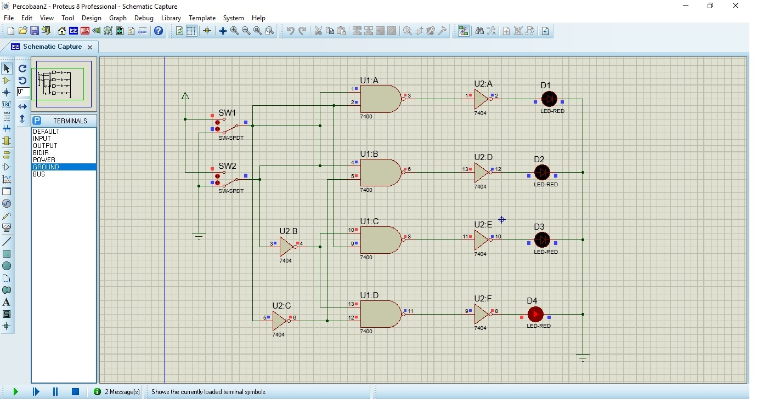

|  |  |  |  |  |  |
| --- | --- | --- | --- | --- | --- |
| INPUT | | OUTPUT | | | |
| SW1 | SW2 | D1 | D2 | D3 | D4 |
| 0 | 0 | 0 | 0 | 0 | 1 |
| 0 | 1 | 1 | 0 | 0 | 0 |
| 1 | 0 | 1 | 0 | 0 | 0 |
| 1 | 1 | 1 | 0 | 0 | 0 |

Percobaan 3

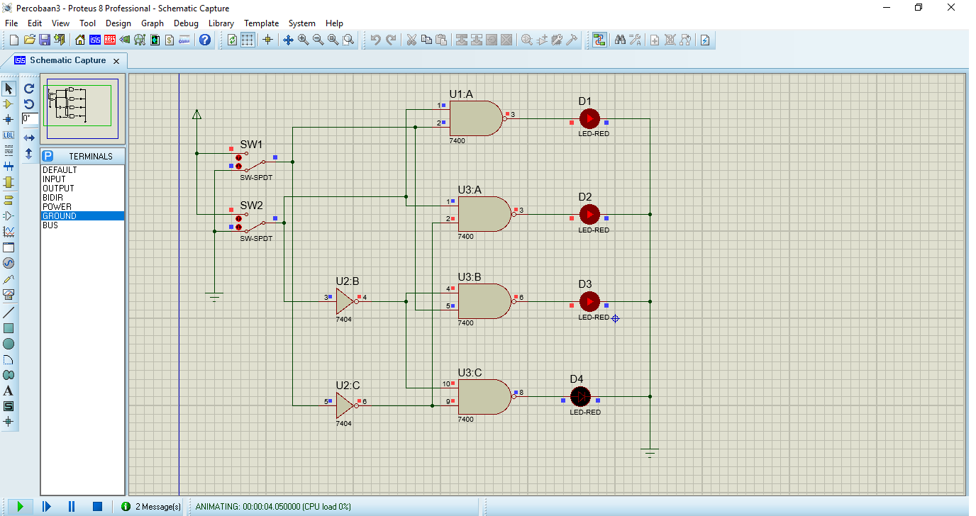

|  |  |  |  |  |  |
| --- | --- | --- | --- | --- | --- |
| INPUT | | OUTPUT | | | |
| SW1 | SW2 | D1 | D2 | D3 | D4 |
| 0 | 0 | 1 | 1 | 1 | 0 |
| 0 | 1 | 1 | 0 | 1 | 1 |
| 1 | 0 | 1 | 1 | 0 | 1 |
| 1 | 1 | 0 | 1 | 1 | 1 |

Percobaan 4

1.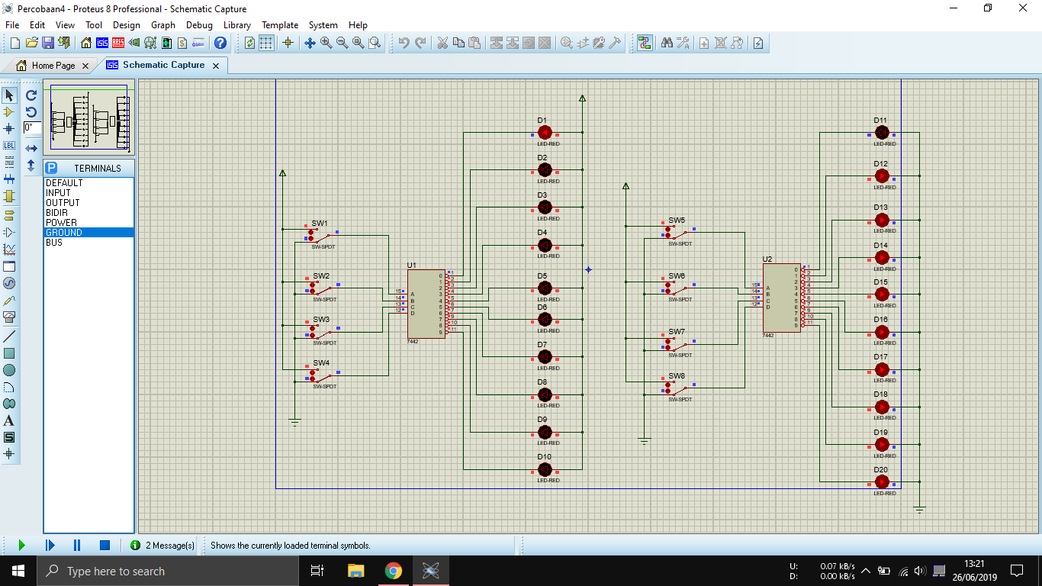

2. a. Anode LED

|  |  |  |  |  |  |  |  |  |  |  |  |  |  |
| --- | --- | --- | --- | --- | --- | --- | --- | --- | --- | --- | --- | --- | --- |
| **Input** | | | | **Output** | | | | | | | | | |
| **SW4** | **SW3** | **SW2** | **SW1** | **0** | **1** | **2** | **3** | **4** | **5** | **6** | **7** | **8** | **9** |
| 0 | 0 | 0 | 0 | 1 | 0 | 0 | 0 | 0 | 0 | 0 | 0 | 0 | 0 |
| 0 | 0 | 0 | 1 | 0 | 1 | 0 | 0 | 0 | 0 | 0 | 0 | 0 | 0 |
| 0 | 0 | 1 | 0 | 0 | 0 | 1 | 0 | 0 | 0 | 0 | 0 | 0 | 0 |
| 0 | 0 | 1 | 1 | 0 | 0 | 0 | 1 | 0 | 0 | 0 | 0 | 0 | 0 |
| 0 | 1 | 0 | 0 | 0 | 0 | 0 | 0 | 1 | 0 | 0 | 0 | 0 | 0 |
| 0 | 1 | 0 | 1 | 0 | 0 | 0 | 0 | 0 | 1 | 0 | 0 | 0 | 0 |
| 0 | 1 | 1 | 0 | 0 | 0 | 0 | 0 | 0 | 0 | 1 | 0 | 0 | 0 |
| 0 | 1 | 1 | 1 | 0 | 0 | 0 | 0 | 0 | 0 | 0 | 1 | 0 | 0 |
| 1 | 0 | 0 | 0 | 0 | 0 | 0 | 0 | 0 | 0 | 0 | 0 | 1 | 0 |
| 1 | 0 | 0 | 1 | 0 | 0 | 0 | 0 | 0 | 0 | 0 | 0 | 0 | 1 |
| 1 | 0 | 1 | 0 | 0 | 0 | 0 | 0 | 0 | 0 | 0 | 0 | 0 | 0 |
| 1 | 0 | 1 | 1 | 0 | 0 | 0 | 0 | 0 | 0 | 0 | 0 | 0 | 0 |
| 1 | 1 | 0 | 0 | 0 | 0 | 0 | 0 | 0 | 0 | 0 | 0 | 0 | 0 |
| 1 | 1 | 0 | 1 | 0 | 0 | 0 | 0 | 0 | 0 | 0 | 0 | 0 | 0 |
| 1 | 1 | 1 | 0 | 0 | 0 | 0 | 0 | 0 | 0 | 0 | 0 | 0 | 0 |
| 1 | 1 | 1 | 1 | 0 | 0 | 0 | 0 | 0 | 0 | 0 | 0 | 0 | 0 |

b. Cathode LED

|  |  |  |  |  |  |  |  |  |  |  |  |  |  |
| --- | --- | --- | --- | --- | --- | --- | --- | --- | --- | --- | --- | --- | --- |
| **Input** | | | | **Output** | | | | | | | | | |
| **SW4** | **SW3** | **SW2** | **SW1** | **0** | **1** | **2** | **3** | **4** | **5** | **6** | **7** | **8** | **9** |
| 0 | 0 | 0 | 0 | 0 | 1 | 1 | 1 | 1 | 1 | 1 | 1 | 1 | 1 |
| 0 | 0 | 0 | 1 | 1 | 0 | 1 | 1 | 1 | 1 | 1 | 1 | 1 | 1 |
| 0 | 0 | 1 | 0 | 1 | 1 | 0 | 1 | 1 | 1 | 1 | 1 | 1 | 1 |
| 0 | 0 | 1 | 1 | 1 | 1 | 1 | 0 | 1 | 1 | 1 | 1 | 1 | 1 |
| 0 | 1 | 0 | 0 | 1 | 1 | 1 | 1 | 0 | 1 | 1 | 1 | 1 | 1 |
| 0 | 1 | 0 | 1 | 1 | 1 | 1 | 1 | 1 | 0 | 1 | 1 | 1 | 1 |
| 0 | 1 | 1 | 0 | 1 | 1 | 1 | 1 | 1 | 1 | 0 | 1 | 1 | 1 |
| 0 | 1 | 1 | 1 | 1 | 1 | 1 | 1 | 1 | 1 | 1 | 0 | 1 | 1 |
| 1 | 0 | 0 | 0 | 1 | 1 | 1 | 1 | 1 | 1 | 1 | 1 | 0 | 1 |
| 1 | 0 | 0 | 1 | 1 | 1 | 1 | 1 | 1 | 1 | 1 | 1 | 1 | 0 |
| 1 | 0 | 1 | 0 | 1 | 1 | 1 | 1 | 1 | 1 | 1 | 1 | 1 | 1 |
| 1 | 0 | 1 | 1 | 1 | 1 | 1 | 1 | 1 | 1 | 1 | 1 | 1 | 1 |
| 1 | 1 | 0 | 0 | 1 | 1 | 1 | 1 | 1 | 1 | 1 | 1 | 1 | 1 |
| 1 | 1 | 0 | 1 | 1 | 1 | 1 | 1 | 1 | 1 | 1 | 1 | 1 | 1 |
| 1 | 1 | 1 | 0 | 1 | 1 | 1 | 1 | 1 | 1 | 1 | 1 | 1 | 1 |
| 1 | 1 | 1 | 1 | 1 | 1 | 1 | 1 | 1 | 1 | 1 | 1 | 1 | 1 |